Version Update Guidelines (Incite 3.0)
Steps
1. You need to follow the instructions below carefully.
Note:- You need to replace or overwrite the file carefully.First you need to copy the file from the folder then paste the folder or file in the given directory path if the server asks about replace or overwrite then you need to click yes or overwrite or replace.

Below is the Folder structure of laravel project

Folder Path => app
Folder Path => database
Folder Path => public
Folder Path => resources
Folder Path => routes

After replacing all folders successfully then you need to follow the second step.

2. You need to hit the query (given below)
Ex:- https://your-domain.com/execute-queries
After hitting this query a success message will come.Remember one thing if you hit this query one time successfully then no need to hit again.

Note:- After following the above steps then you need to go to the language keyword section in the admin panel .(As shown as below ss)
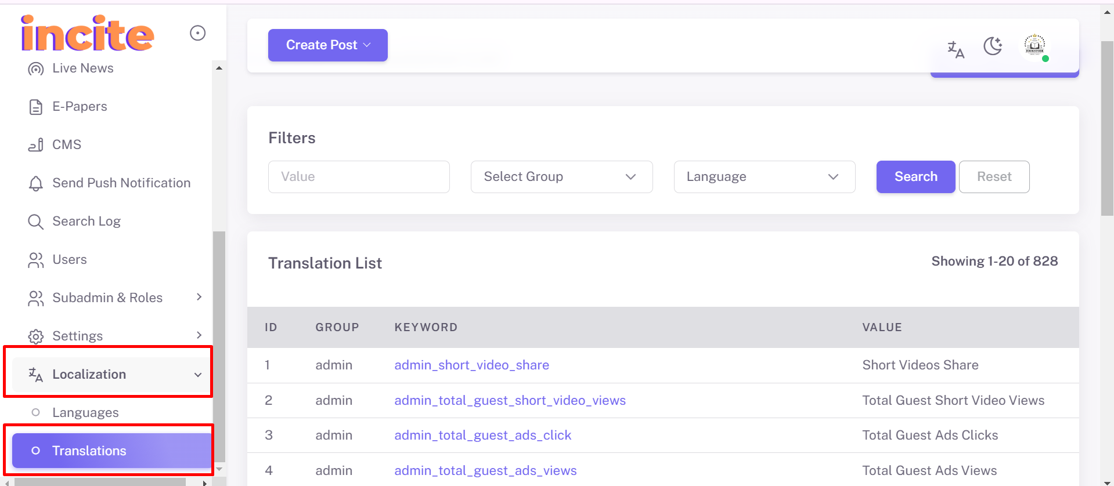

Then you need to edit any one of the keywords and without changing their value directly click on the save changes button.

